Proactive VOLUNTEER MANAGEMENT - Nonprofit Leaders Conference 2024

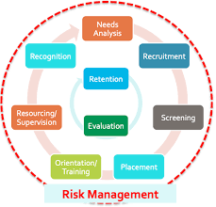

YOUR NOTES: What are you rocking? Where could you improve? What do you need to plan?

Needs Analysis

Recruitment

Screening/Interviewing/Hiring?

Placement – Matching interests with openings

Orientation/Training – Job Description?

Resourcing/Supervision – Mentoring?

Recognition, Appreciation – What’s the difference?

Retention

Evaluation
Judith Bendersky, MPH, Certified Aging & Disabilities Navigator, Certified SHIBA Medicare Counselor, Certified WSU Master Gardener of Thurston County, volunteer Outdoor Adventurer Organizer
Judithbendersky@gmail.com

